

Thermal jacket [sales@metersuk.co.uk](mailto:sales@metersuk.co.uk)

**Thermal Jacket**

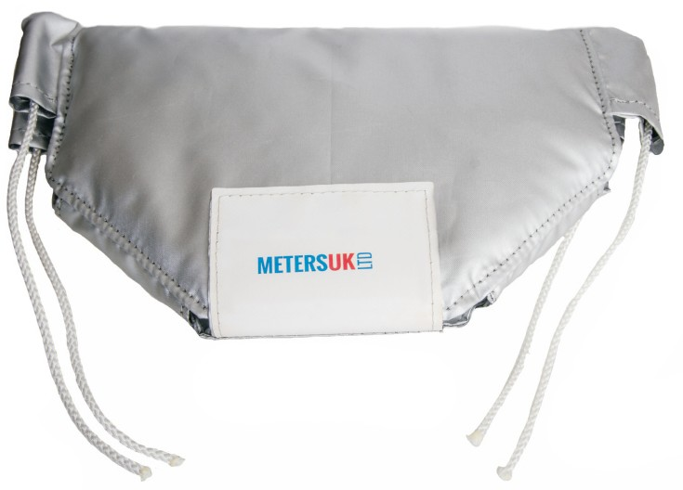Protect your water meters during the cold winter months with Meters UKs Thermal jacket. Hot water meters also require that heating is regulated and the thermal jackets can also jackets can also keep temperatures constant, especially if exposed to extreme temperatures. The thermal jacket gives easy access for manual reading of the meter

**Material**

Polyethylene (PE) Poly Cloth 400g/m³

**Inner Fill:**

25mm thick cellular insulation value w/m²K

**Fixings and Fastenings:**

Velcro hook & loop flaps with draw cord.

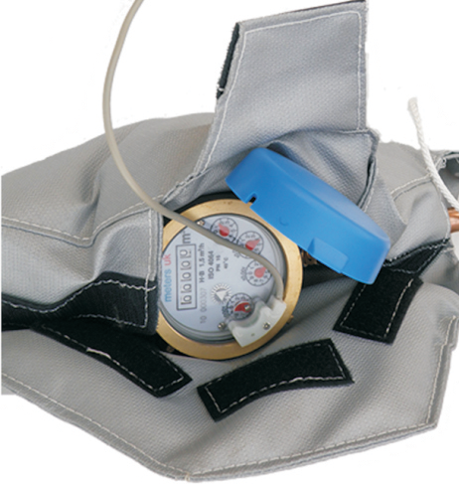**Temperature Range:** - 40°C to 110°C

**Sizes**

Multi-jet flow water meters: 15mm to 50mm

Turbine flow meters:

**Diagrams**

Fully Open: Fully closed:

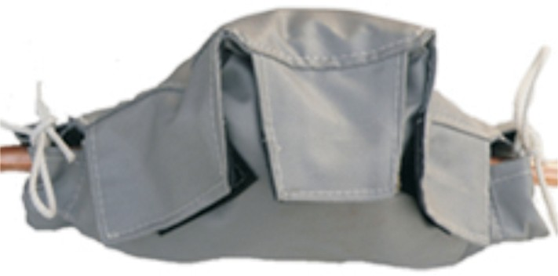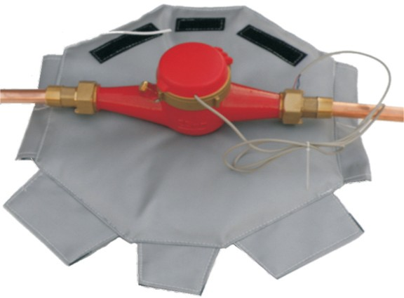

[sales@metersuk.co.uk](mailto:sales@metersuk.co.uk) Whitegate, White Lund Industrial Estate, Morecambe LA3 3BT 01524 555929